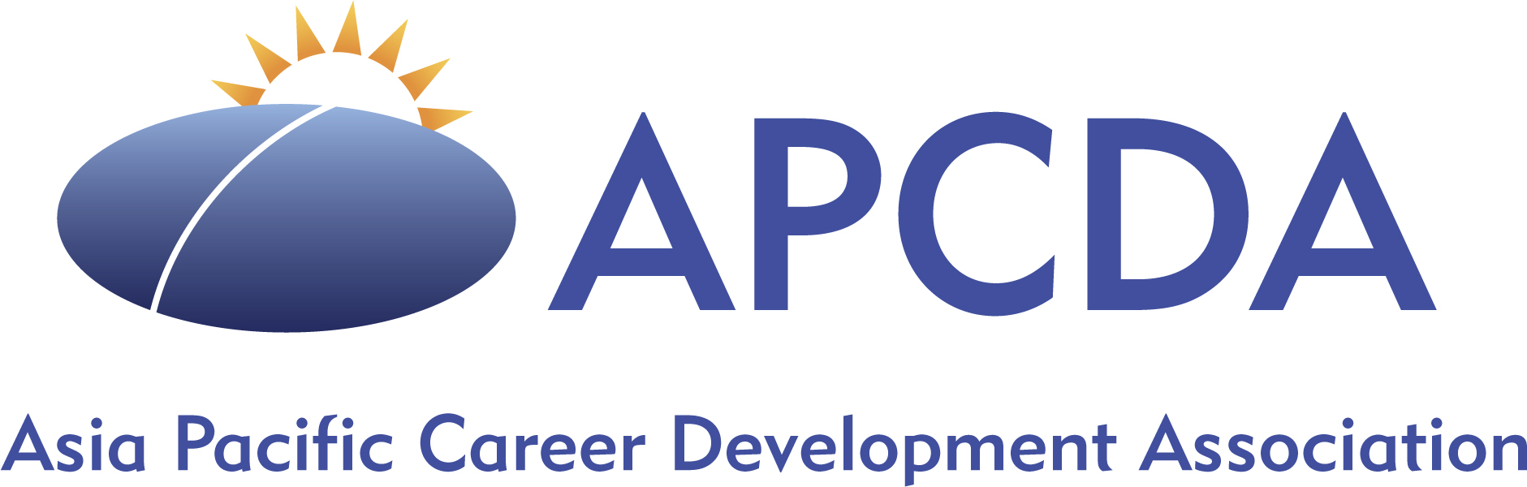

APCDA Board Meeting

April 21/22

President’s Message (Allan)

Excited about APCDA's growing momentum and energy

Positive developments include an expansive vision, recognition of individual talent, interesting projects, and efforts to improve efficiency and sustainability. The leadership development work and the mentoring program are examples of progress.
- The upcoming conference and leadership retreat offer potential for growth and collaboration

Treasurer’s Report (Nila) (See Financial Reports)

Conference income is beginning to arrive, and we are expecting more registrants

We are in a good financial position overall

Discussion: International Collaboration Workgroup
- The board formally approves Arun and Sini as co-chairs for the International Collaboration Workgroup
- We have received four nominations for the task force so far

Discussion: Mentorship Project
- Elisabeth and Brian are developing this mentorship program
- The program will have three categories: individual mentorships, leadership mentoring, and broader group mentorship for Area Council.
- Plan to introduce the concept at the conference
- Agreed to simplify the approach and offer only 3 types of activities the first year.
- Only Area Representatives will be involved in the first year,

2025 Conference Plans

Allan will prepare the Opening Ceremony and highlight the conference theme.
- Elisabeth and Serene will assist with cultural aspects.

2026 Conference

Venue: Universiti Malaya, Kuala Lumpur

Hall size: 350

April 27 – May 8, 2026

Theme: Inclusive Career Development Practices and focus on disabilities.

The Universiti Malaya has provided 3 keynote speakers
- We chose to add one keynote to reduce costs and because we do not want as many keynotes as in 2025. Candidates discussed were:
- Dr. Roberta Borgen
- Jane Horan
- Dr. William Donald
- The group chose Dr. William Donald
- It was also discussed that we might incorporate the use of technology and AI for empowering marginalized groups.

